10.75: a) Use conservation of energy to find the speed 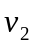 of the ball just before it leaves the top of the cliff. Let point 1 be at the bottom of the hill and point 2 be at the top of the hill. Take  at the bottom of the hill, so 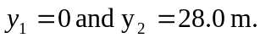
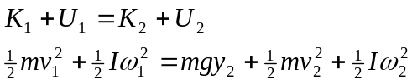
Rolling without slipping means
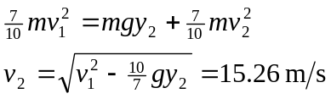
Consider the projectile motion of the ball, from just after it leaves the top of the cliff until just before it lands. Take 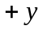 to be downward.
Use the vertical motion to find the time in the air:
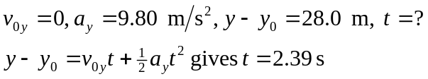
During this time the ball travels horizontally
Just before it lands, 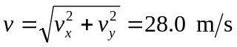
b) At the bottom of the hill, 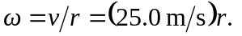The rotation rate doesn't change while the ball is in the air, after it leaves the top of the cliff, so just before it lands 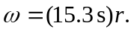 The total kinetic energy is the same at the bottom of the hill and just before it lands, but just before it lands less of this energy is rotational kinetic energy, so the translational kinetic energy is greater.

